MODULE-5
231FA04F17
Shaik Sameera
sameerashaik1005@gmail.com
Lab 1: Understanding ORM with a Retail Inventory System
- Create a .NET Console App:
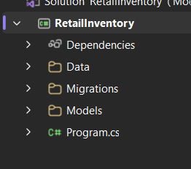
- Install EF Core Packages:
- Install-package Microsoft.EntityFrameworkCore.SqlServer
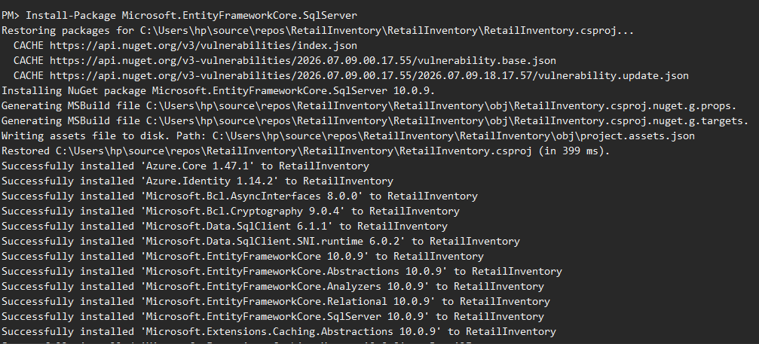
- Install-package Microsoft.EntityFrameworkCore.Design
\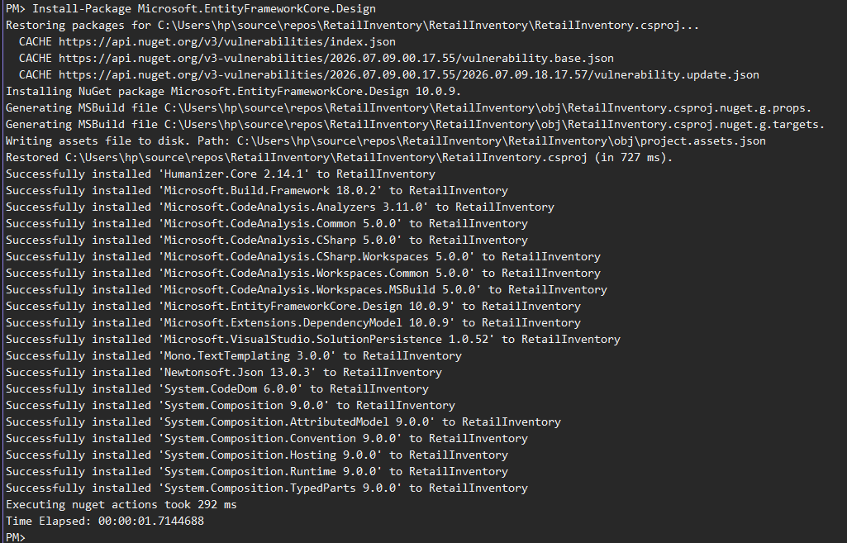
Lab 2: Setting Up the Database Context for a Retail Store
Step: 1. Create Models:
Product.cs :
namespace RetailInventory.Models {
public class Product {
public int Id { get; set; }
public string Name { get; set; } = string.Empty;
public decimal Price { get; set; }
public int CategoryId { get; set; }
public Category Category { get; set; } = null!;
}
}
Category.cs :
using System.Collections.Generic;
namespace RetailInventory.Models{
public class Category {
public int Id { get; set; }
public string Name { get; set; } = string.Empty;
public List<Product> Products { get; set; } = new();
}
}
Step: 2. Create AppDbContext:
using Microsoft.EntityFrameworkCore;
using RetailInventory.Models;
namespace RetailInventory.Data {
public class AppDbContext : DbContext{
public DbSet<Product> Products { get; set; }
public DbSet<Category> Categories { get; set; }
protected override void OnConfiguring(DbContextOptionsBuilder optionsBuilder) {
optionsBuilder.UseSqlServer(
"Server=localhost\\SQLEXPRESS;Database=RetailInventoryDB;Trusted_Connection=True;TrustServerCertificate=True");
}
}
}
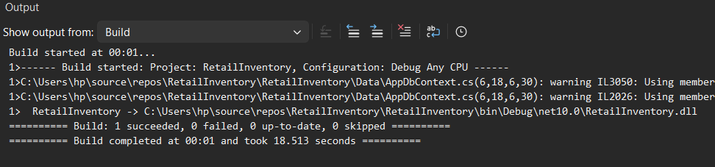
Lab 3: Using EF Core CLI to Create and Apply Migrations
Steps:
- Install EF Core CLI (if not already):
dotnet tool install --global dotnet-ef
- Create Initial Migration:
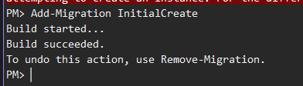
- Apply Migration to Create Database:
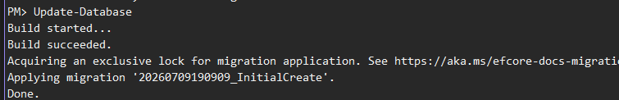
Lab 4: Inserting Initial Data into the Database
Steps:
- Insert Data in Program.cs:
using RetailInventory.Data;
using RetailInventory.Models;
using var context = new AppDbContext();
var electronics = new Category{
Name = "Electronics"
};
var groceries = new Category{
Name = "Groceries"
};
await context.Categories.AddRangeAsync(electronics, groceries);
var product1 = new Product
{
Name = "Laptop",
Price = 75000,
Category = electronics
};
var product2 = new Product
{
Name = "Rice Bag",
Price = 1200,
Category = groceries
};
await context.Products.AddRangeAsync(product1, product2);
await context.SaveChangesAsync();
Console.WriteLine("Data Inserted Successfully!");
- Run the App:
dotnet run
- Verify in SQL Server:
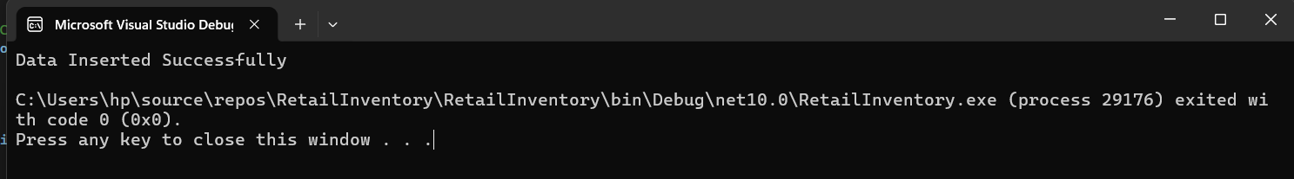

Lab 5: Retrieving Data from the Database
Steps:
1. Retrieve All Products
2. Find by ID
3. FirstOrDefault with Condition:
using Microsoft.EntityFrameworkCore;
using RetailInventory.Data;
using var context = new AppDbContext();
var products = await context.Products.ToListAsync();
Console.WriteLine("------ All Products ------");
foreach (var p in products){
Console.WriteLine($"ID: {p.Id}");
Console.WriteLine($"Name: {p.Name}");
Console.WriteLine($"Price: ₹{p.Price}");
Console.WriteLine("-------------------------");
}
var product = await context.Products.FindAsync(1);
Console.WriteLine("\nFindAsync Result");
Console.WriteLine($"Product Name: {product?.Name}");
var expensive = await context.Products.FirstOrDefaultAsync(p => p.Price > 50000);
Console.WriteLine("\nFirstOrDefaultAsync Result");
Console.WriteLine($"Expensive Product: {expensive?.Name}");
